**Purify Cleaning Services**

1. **Homepage:**

**Tagline.** You Make The Mess, We Do the Rest!

High-quality images showcasing your cleaning services in Nairobi.(**We can use online pics for now)**

**Clear call-to-action buttons**

Phone number: 0704084114(whatsapp and to call)

Purify – Where Cleanliness Meets Perfection! Contact us for a free quote and let us purify your space with our exceptional cleaning services. Your satisfaction is our priority, and we're ready to transform your environment.

**A brief introduction of company and its values.**

Purify Cleaning Service is a premier cleaning company in Nairobi, dedicated to delivering exceptional residential and commercial cleaning solutions. We have the experience and skills, and we've become a trusted name in the industry, known for our meticulous attention to detail and unmatched customer satisfaction.

**Mission:**

Our mission at Purify is to elevate the standard of cleanliness in both commercial and residential spaces. We strive to create healthier and more comfortable living and working environments for our clients by providing top-notch cleaning services tailored to their unique needs.

**Core Values:**

Excellence: We are committed to delivering cleaning services of the highest quality, ensuring our clients experience a noticeable difference.

Reliability: Purify is a name you can trust. We consistently meet and exceed expectations, delivering on our promises with punctuality and professionalism.

Customer-Centric: Our clients are at the heart of everything we do. We tailor our services to meet their specific requirements, providing personalized and attentive care.

**Vision:**

Our vision is to be the leading cleaning service provider in Nairobi, setting new standards for excellence and innovation in the industry. We aim to be the go-to choice for those seeking a clean, healthy, and vibrant living or working space.

2. Services Page:

1. **Office Cleaning:**

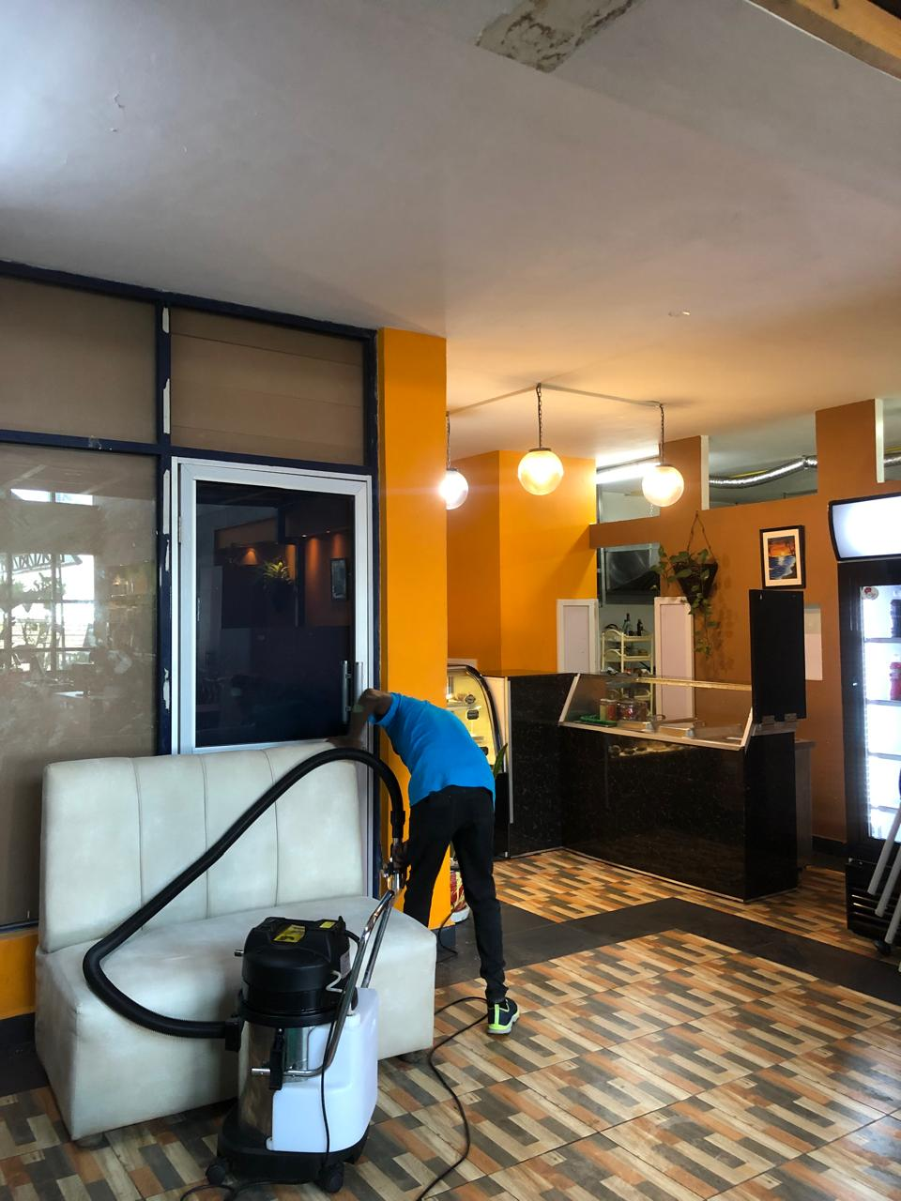

A pristine and organized workspace fosters a productive environment, enhances employee morale, and leaves a positive impression on clients. Regular office cleaning by Purify ensures a clean, professional, and inviting workplace, promoting a healthy work atmosphere.

**2. House Cleaning:**

Our house cleaning services create a comfortable and hygienic home environment. From eliminating dust and allergens to maintaining a spotless living space, Purify's attention to detail ensures that your home is a haven for relaxation and well-being.

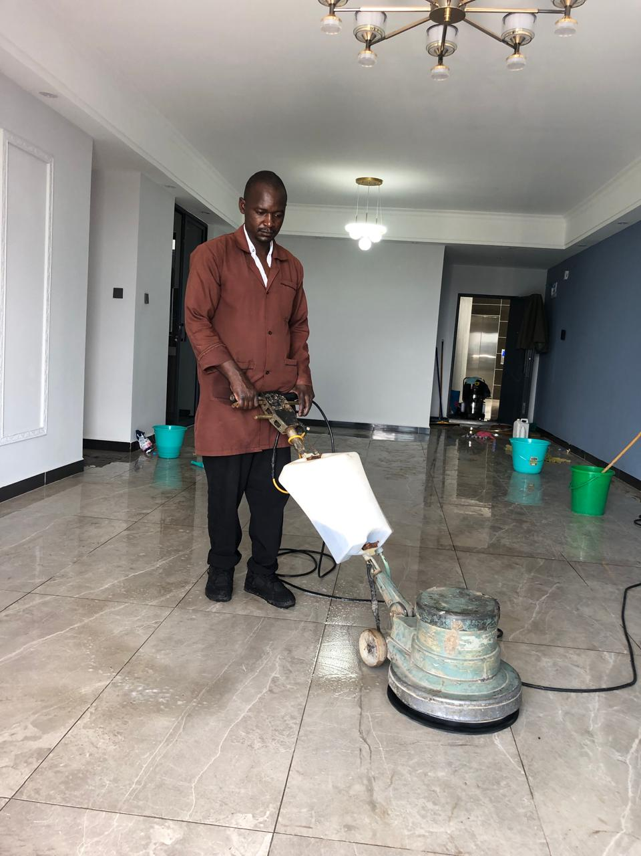

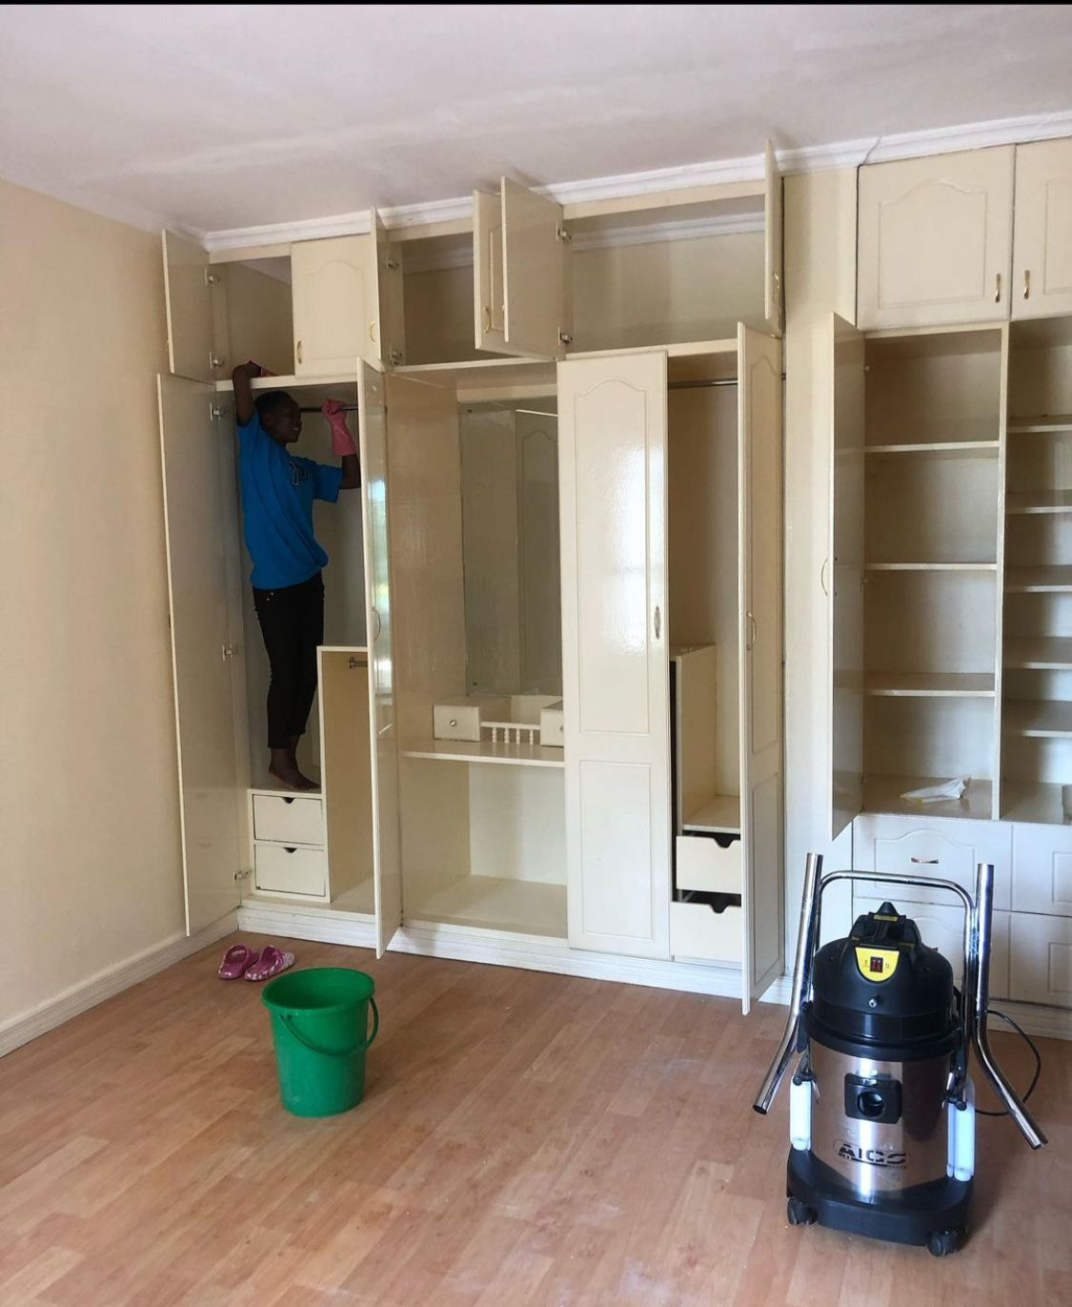

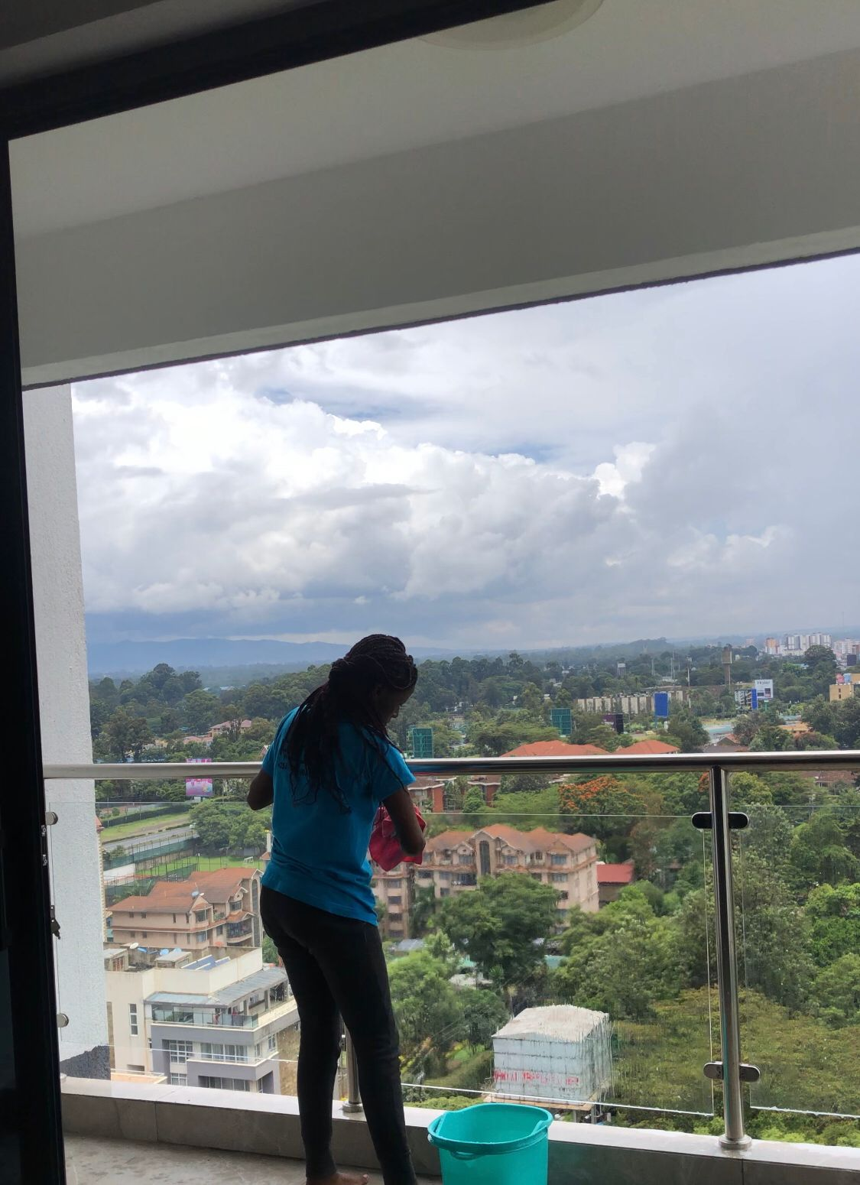

**3. Sofa Cleaning:**

Revive Your Living Spaces with Professional Sofa Cleaning Services in Nairobi!

Your sofa is more than just furniture – it's the centerpiece of your living room, where cherished memories are made and relaxation begins. But over time, everyday wear and tear, spills, and pet dander can take their toll, leaving your sofa looking tired and dull.

At Purify we understand the importance of a clean and inviting home. That's why we offer expert sofa cleaning services in Nairobi to restore your furniture to its former glory.

Our team of experienced cleaners uses advanced techniques and eco-friendly products to deep clean your sofa, removing dirt, stains, and odors without compromising the fabric's integrity. Whether it's a fabric or leather sofa, we have the expertise to handle it with care.

With our professional sofa cleaning services, you can:

* Extend the lifespan of your sofa
* Maintain a hygienic environment for your family
* Eliminate allergens and bacteria
* Restore the beauty of your living space

Don't let a dirty sofa dampen your home's comfort and style. Contact us today to schedule your sofa cleaning service and experience the difference

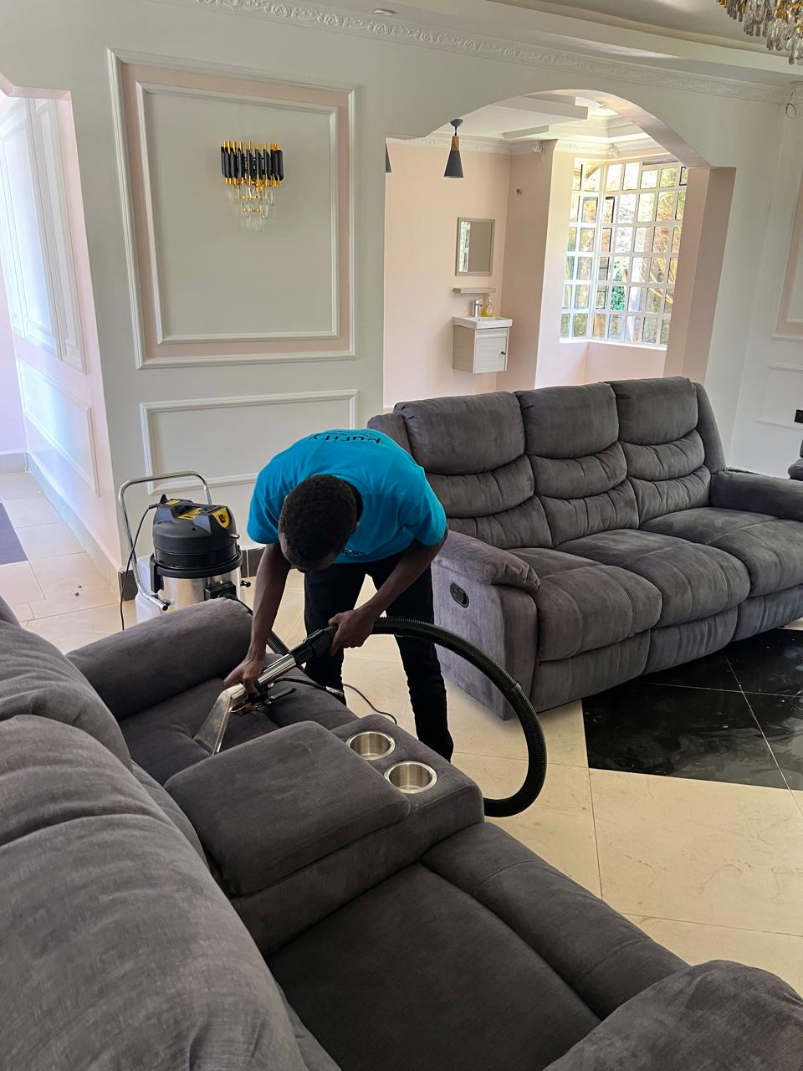

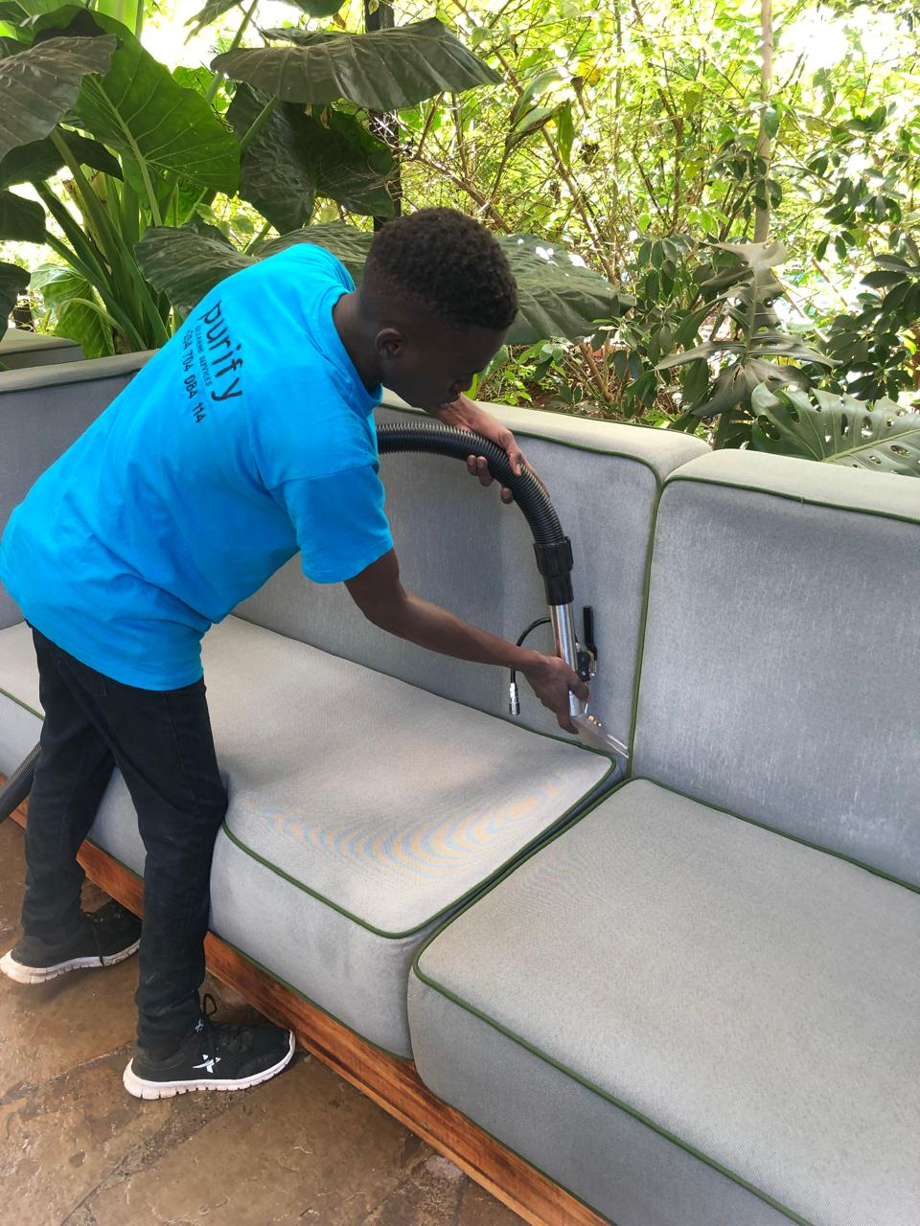



**4. Carpet Cleaning:**

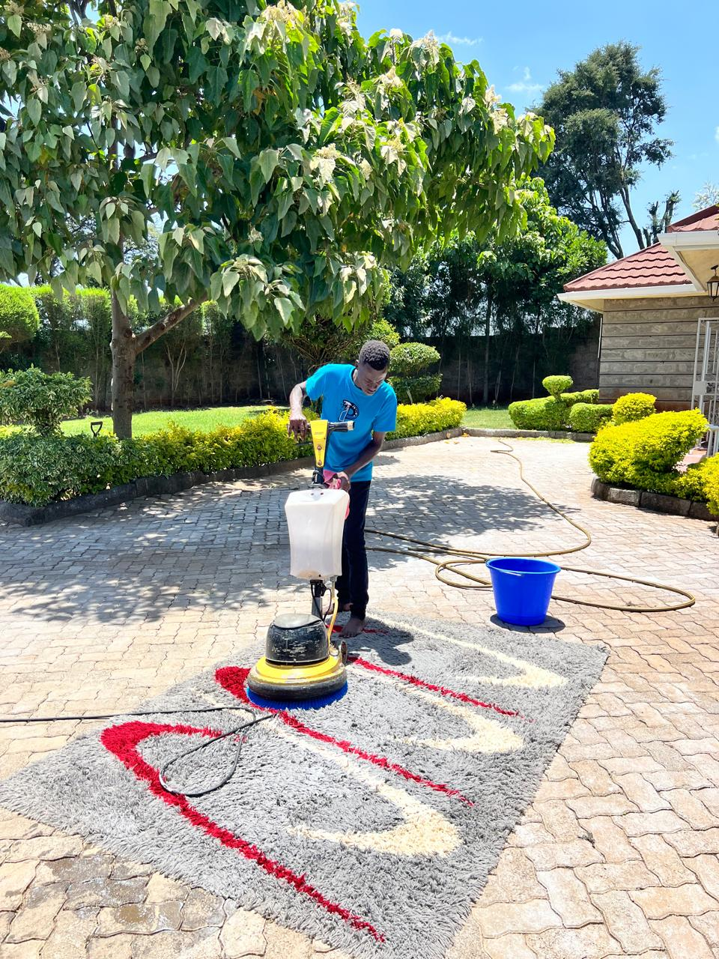

Regular carpet cleaning not only enhances the appearance of your space but also extends the life of your carpets. Purify's carpet cleaning services remove deep-seated dirt, stains, and allergens, contributing to a healthier indoor environment and maintaining the longevity of your carpets.

5. **Post-Construction Cleaning:**

After construction or renovation, debris and dust can linger. Purify's post-construction cleaning ensures a thorough cleanup, allowing you to enjoy your newly transformed space without the hassle of post-build mess. Experience the full beauty of your project with our meticulous cleaning.

6. **Deep House Disinfection**

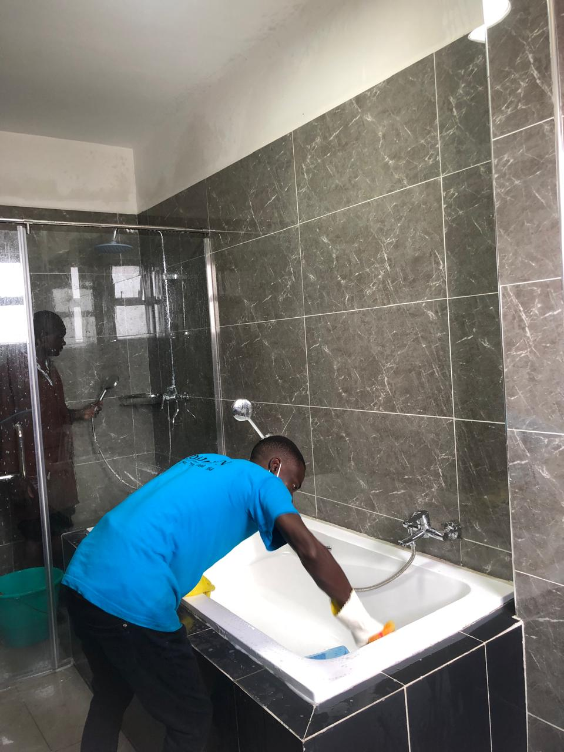

In today's world, health and safety are paramount. Purify's deep house disinfection service goes beyond regular cleaning, targeting and eliminating harmful bacteria and viruses. Ensure a clean and sanitized living space for your family, minimizing the risk of infections.

**Why Choose Purify:**

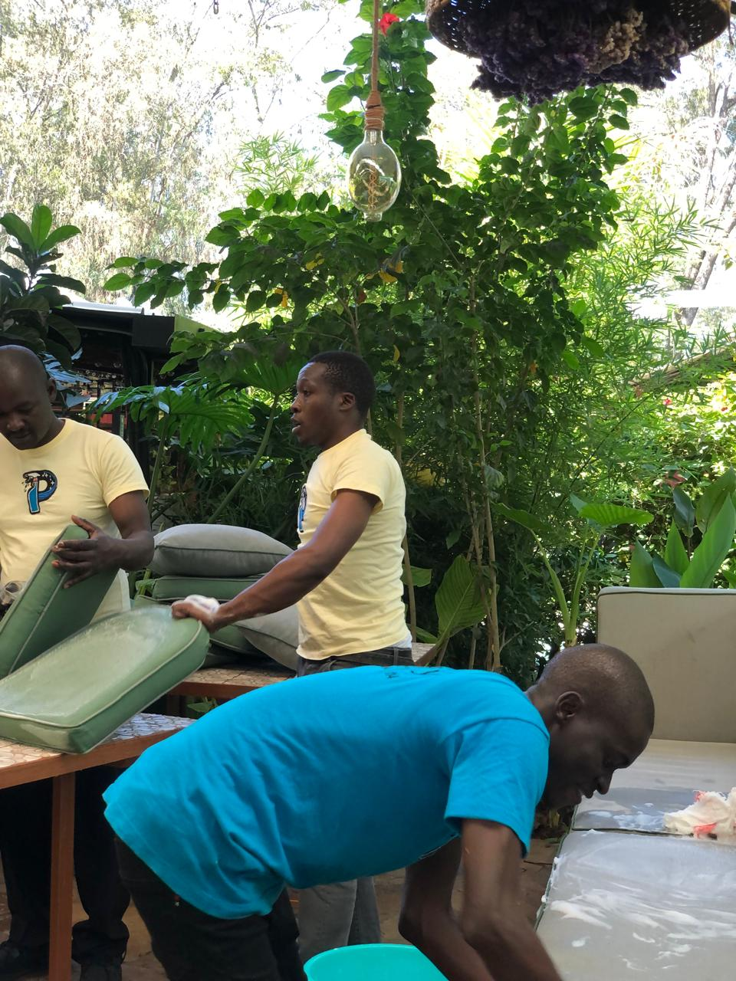

Experienced Professionals: Purify Cleaning Service boasts a team of highly trained and experienced professionals dedicated to delivering exceptional results.

Customized Solutions: We understand that every space is unique. Purify tailors its services to meet the specific needs of each client, ensuring satisfaction.

Eco-Friendly Approach: Purify is committed to using environmentally friendly cleaning products, promoting a healthier environment for both clients and the planet.

Reliability: Trust Purify for reliable and consistent cleaning services. We prioritize punctuality, professionalism, and the highest standards of cleanliness.

Choose Purify for a cleaner, healthier, and more vibrant space. Your satisfaction is our priority!

Before-and-after photos to showcase your expertise.**(we will source them online)**

Pricing information or a link to a quote request form.(**WORKING ON IT)**

3. About Us:

Your company's background, mission, and values.(CHECK ON PAGE ABOVE)

Profiles of key team members.(once i have we will update)

Testimonials from satisfied clients.(on website and will add more

4**. Contact Us:**

phone numbers: 0704084114

email, purify2clen@gmail.com

physical address. Naivasha rd,corner heights.

A contact form for inquiries or service requests.

(could you help me generate one)

A Google Maps embed for easy location reference.